**Practiced Linux commands**

1. / ( Forward slash) - Root directory

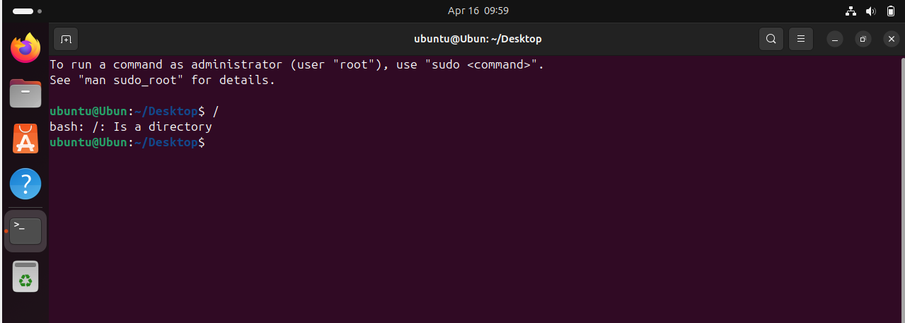

2. ~ (Tild)-- Home Directory

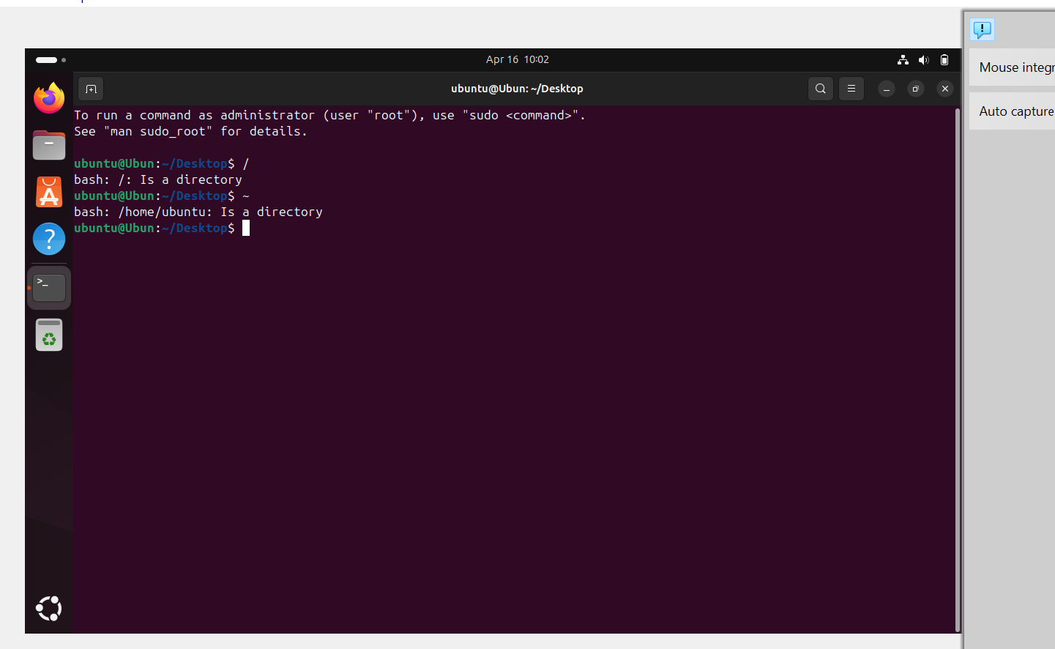

3. pwd – present working directory

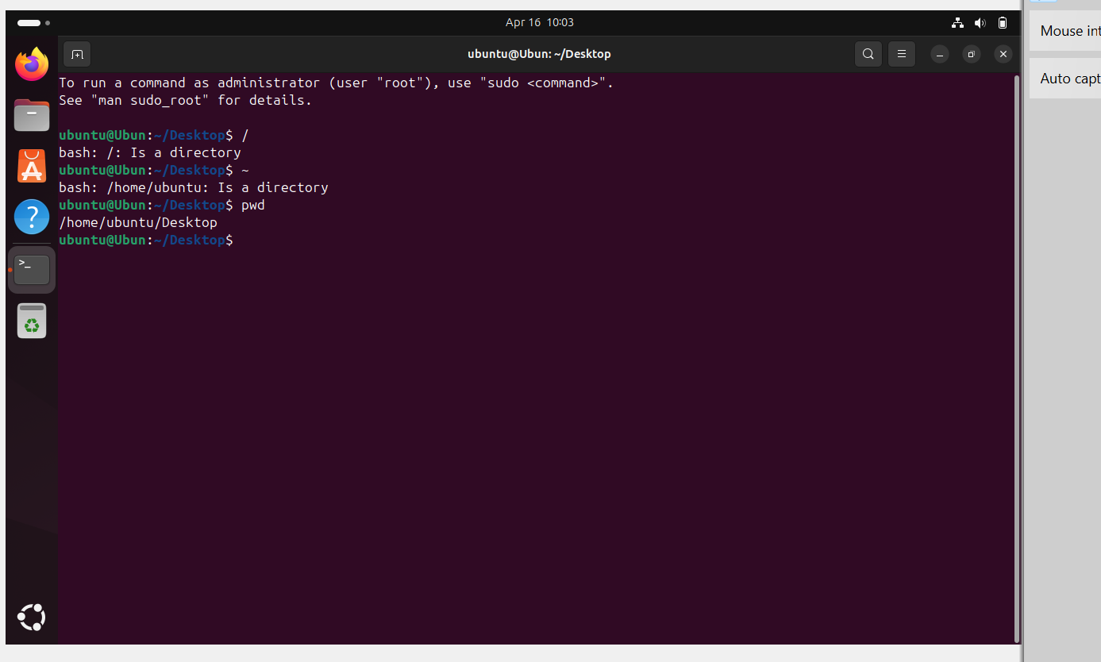4. cd – change directory from one to another

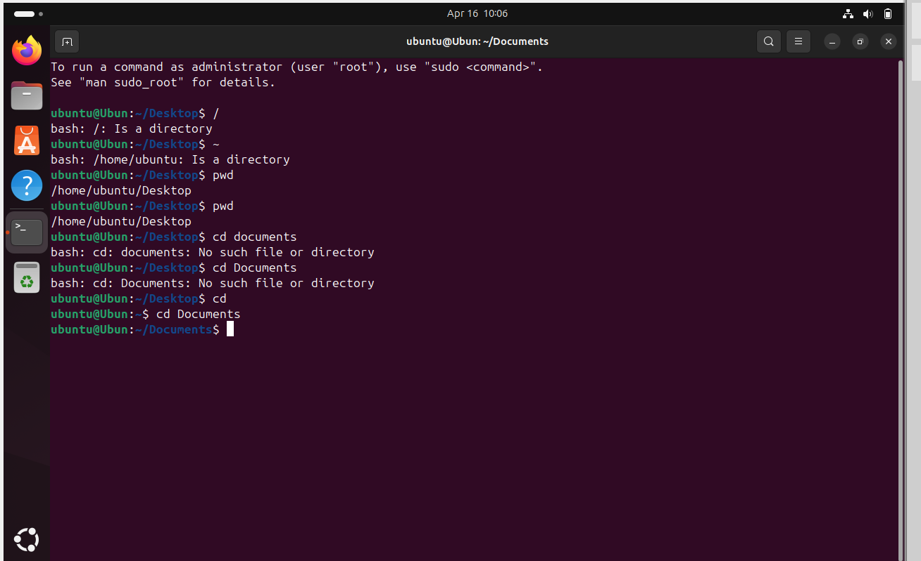 5. cd .. --help us to go back to previous directory.

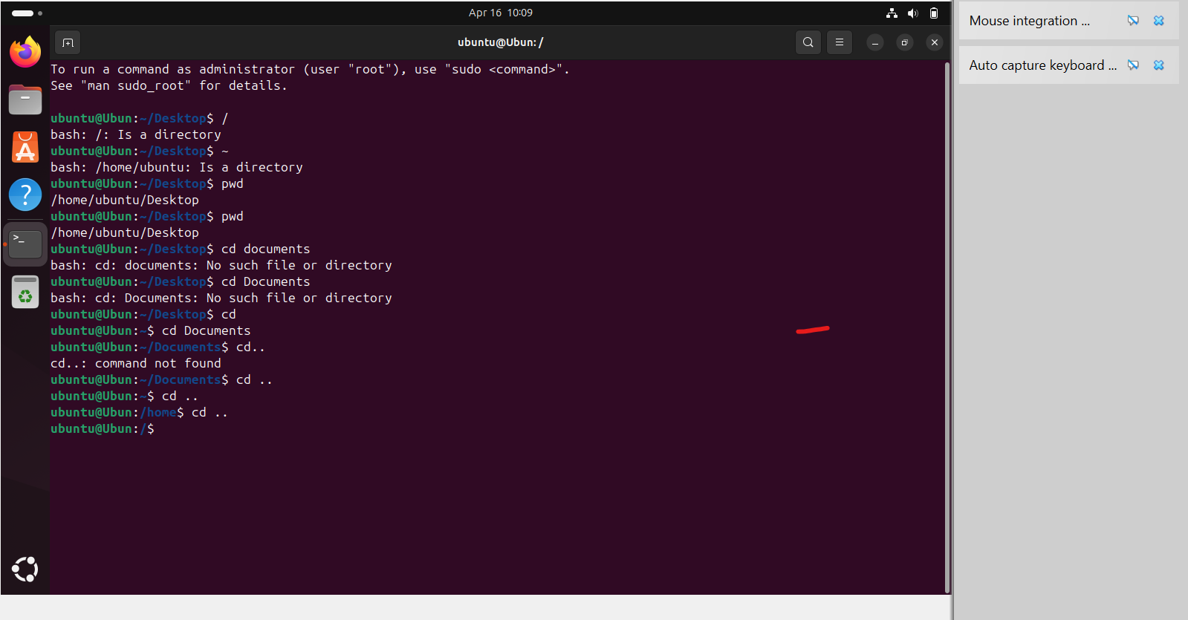

6. ls – list of all files available in directory

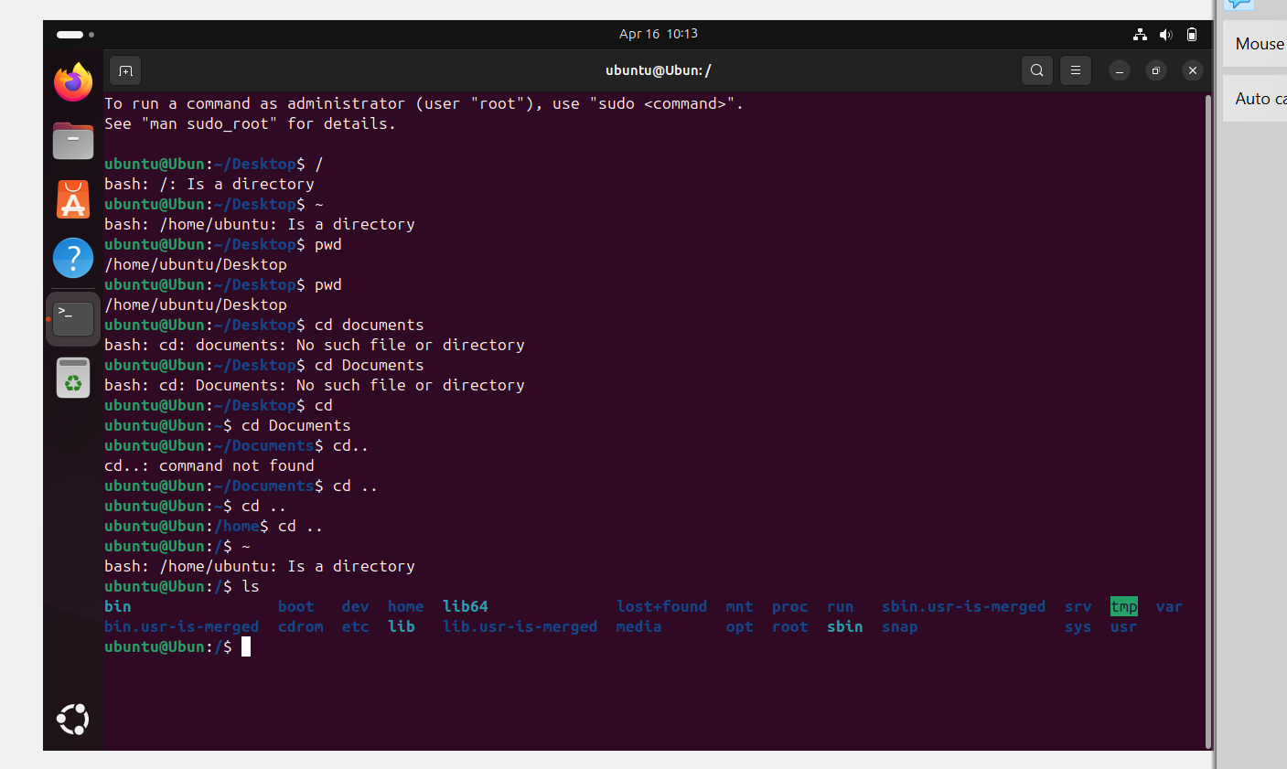

7.ll- long list

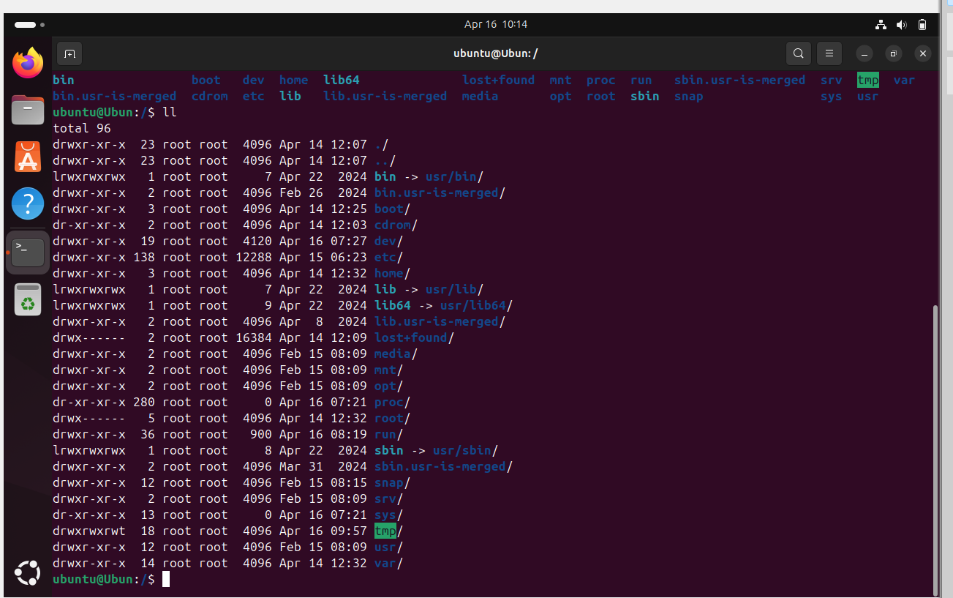8.ls -ltr -- to show the latest modified list in a directory

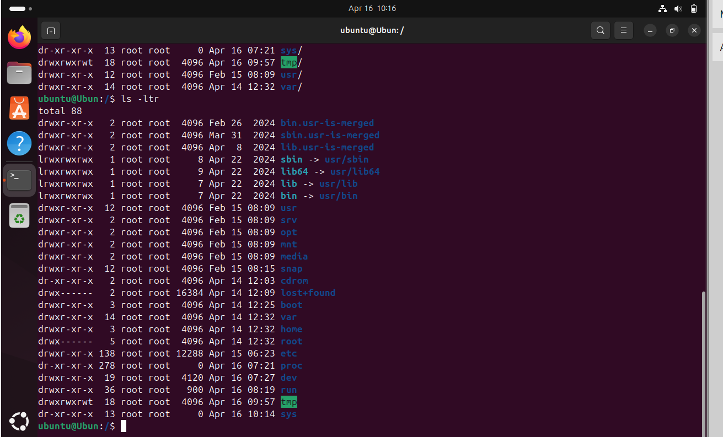9. ls -l – to show the complete list in a directory

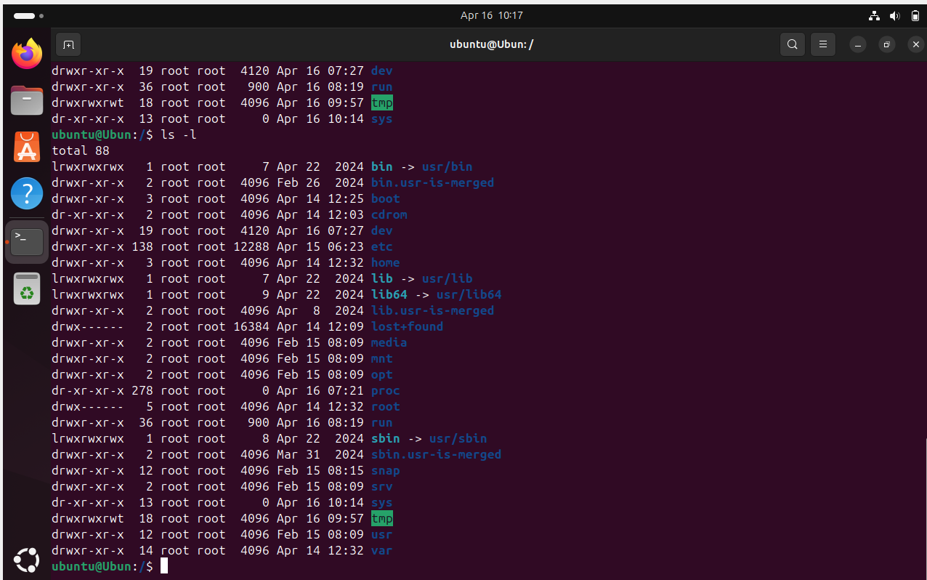

10. ls –a--- to hide the directories

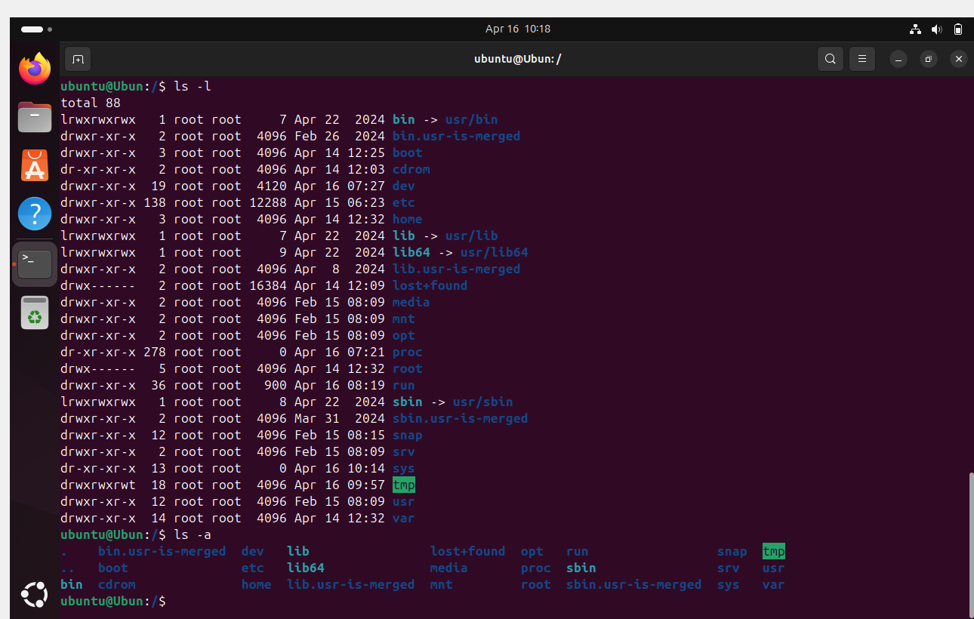

11. mkdir – to create new directory

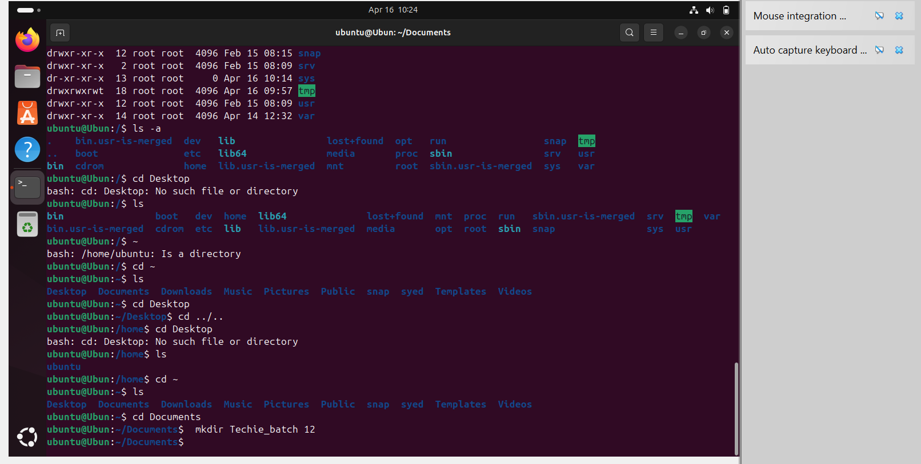

12. Cd ../.. -- to go to previous directory 2 step back

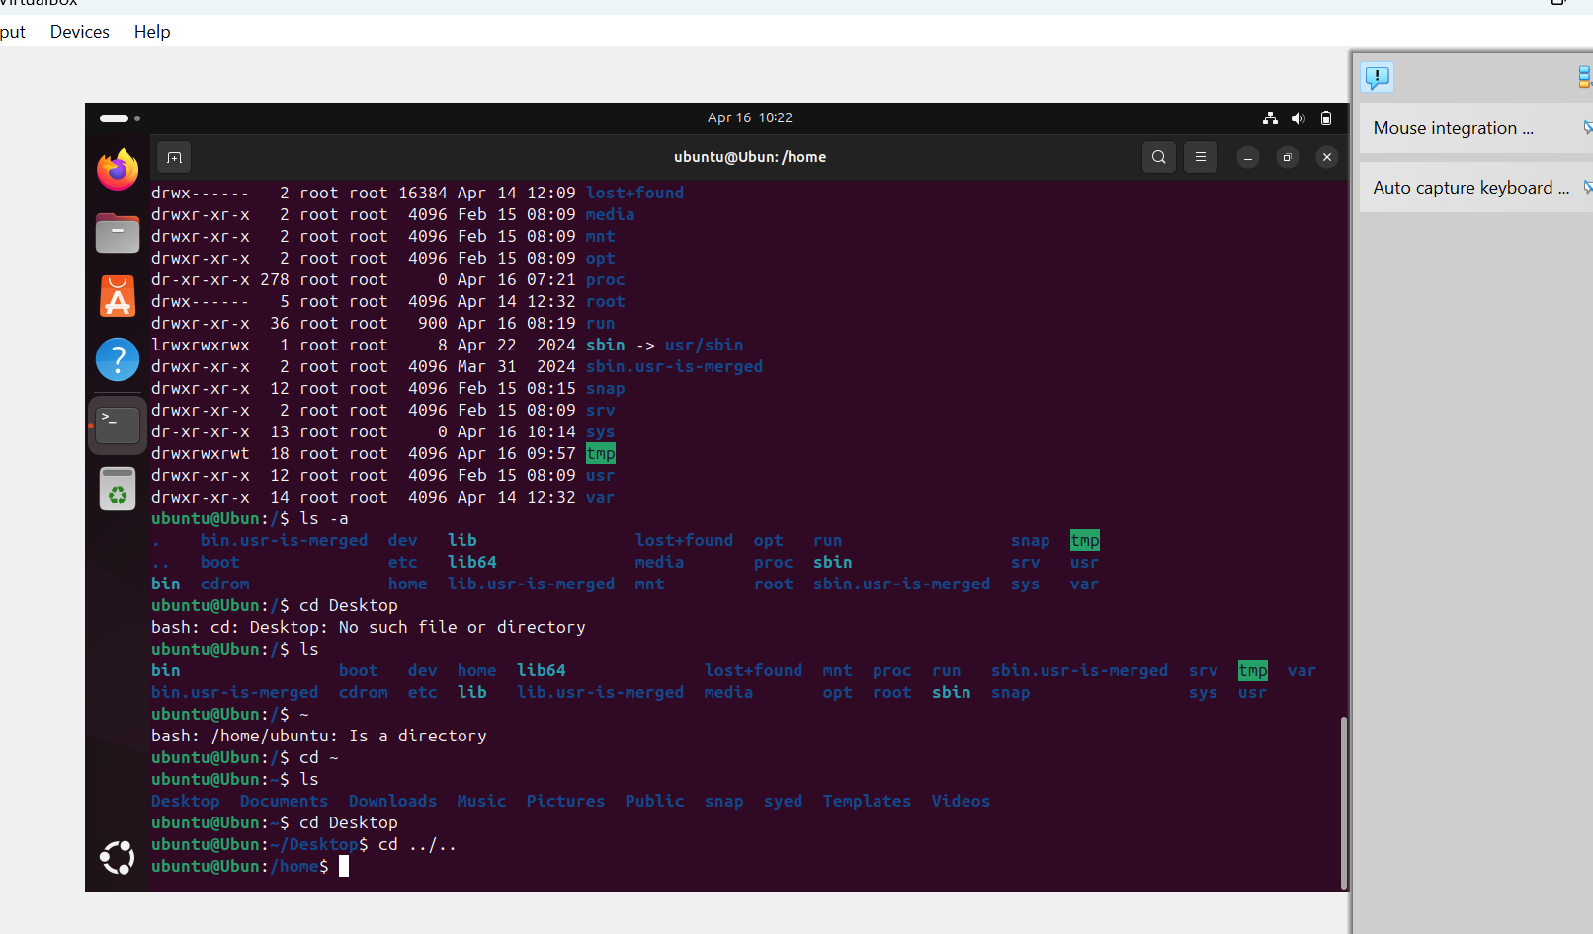13. mv -- To hide files add ’.’ before file name

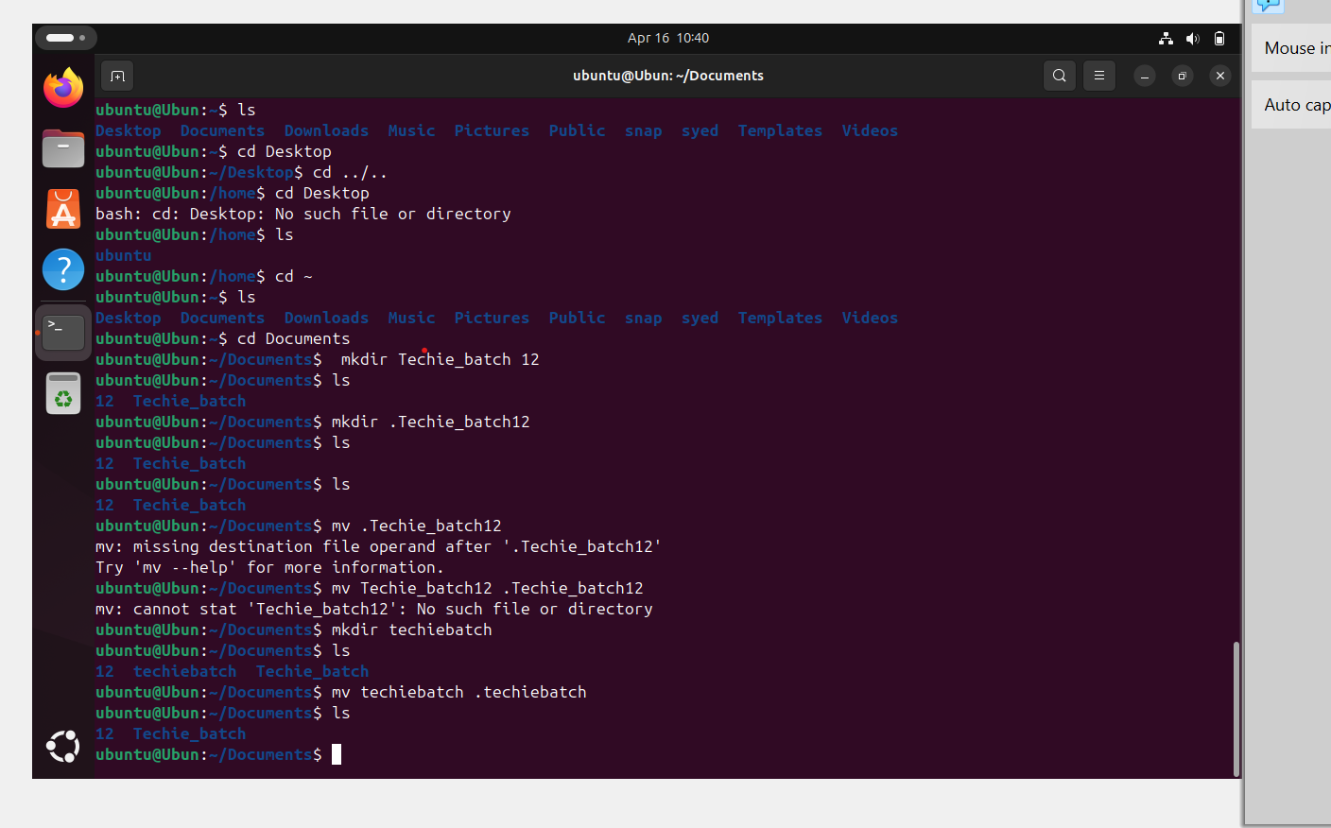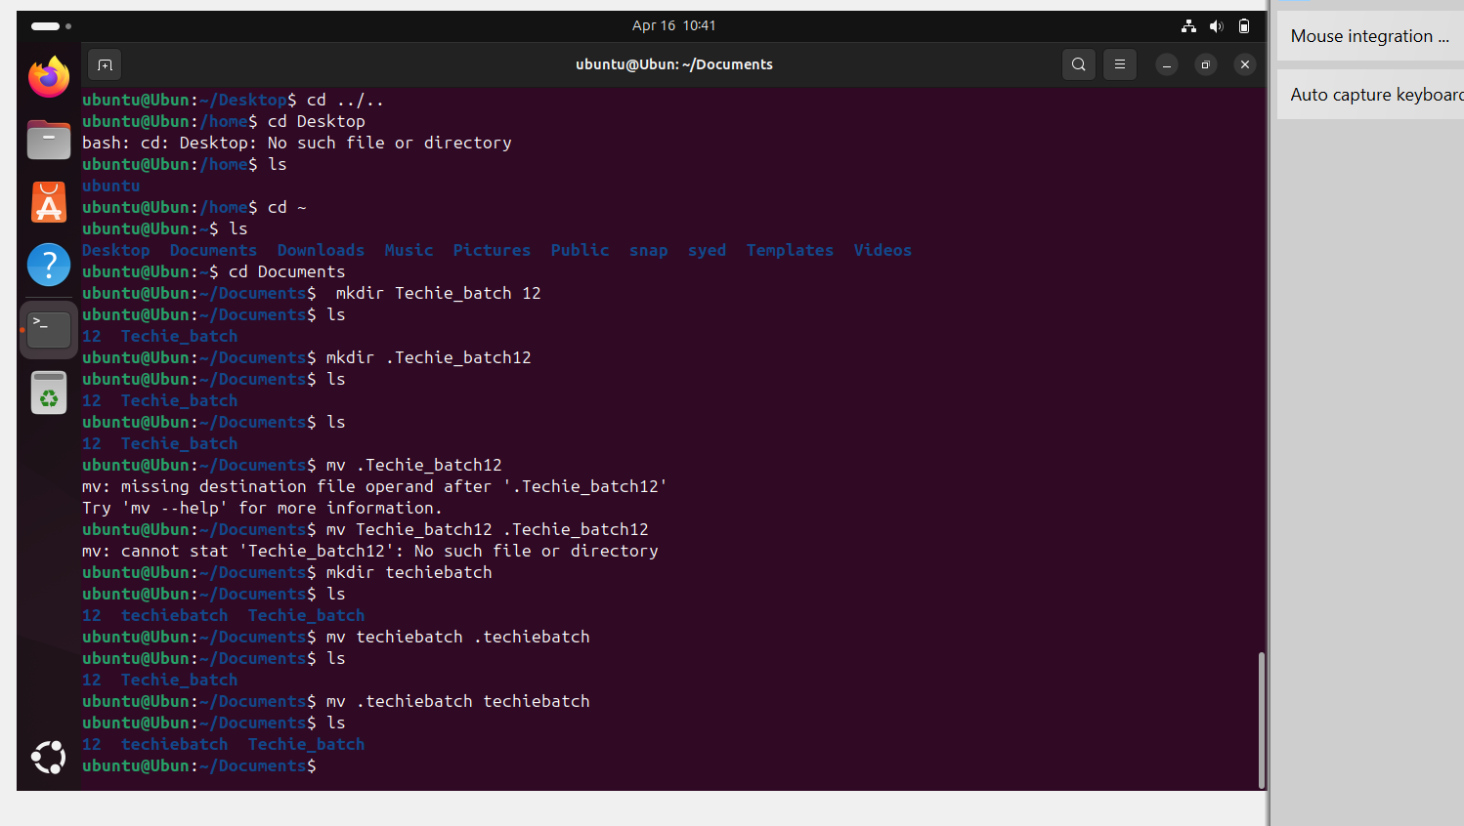

14. history – to show the history of the commands in terminal

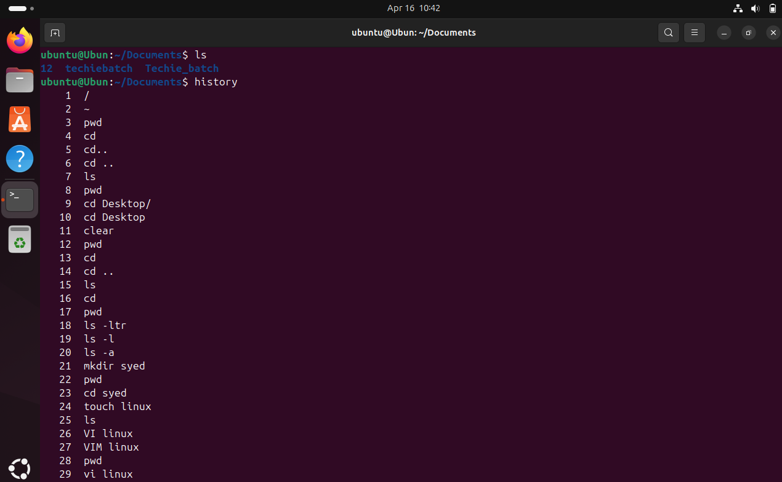

16. date : to show the date

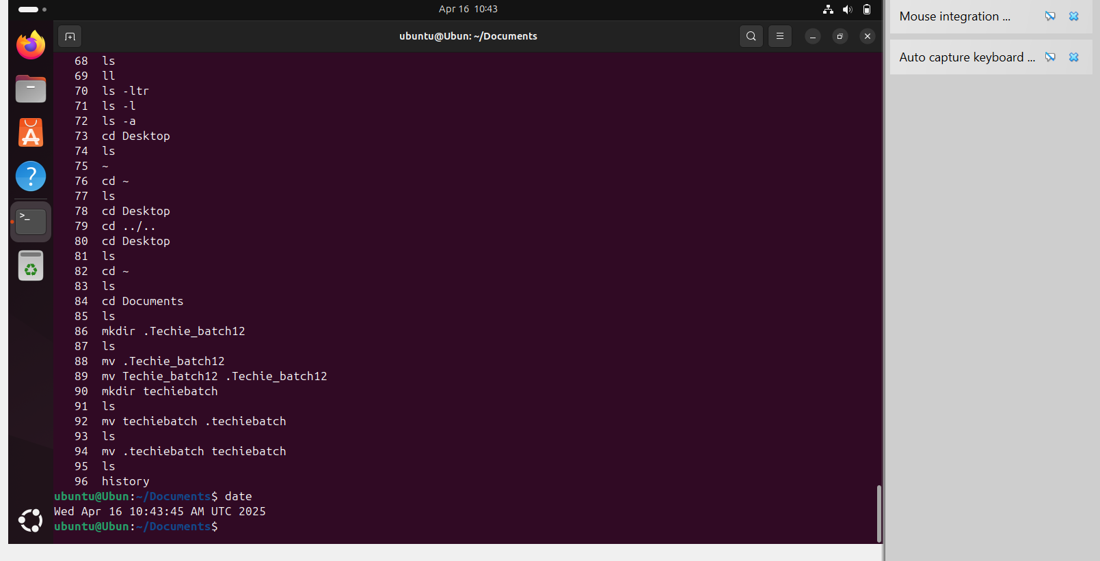

17. rm –rf --- to removie files

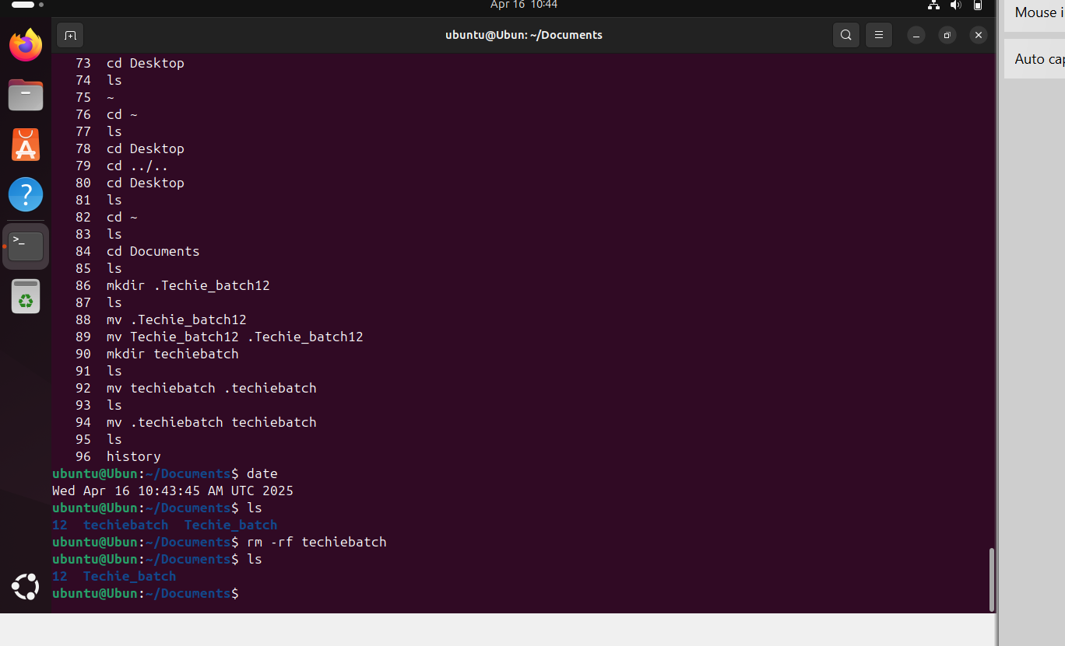20. cp –copy the files/directories from one to another

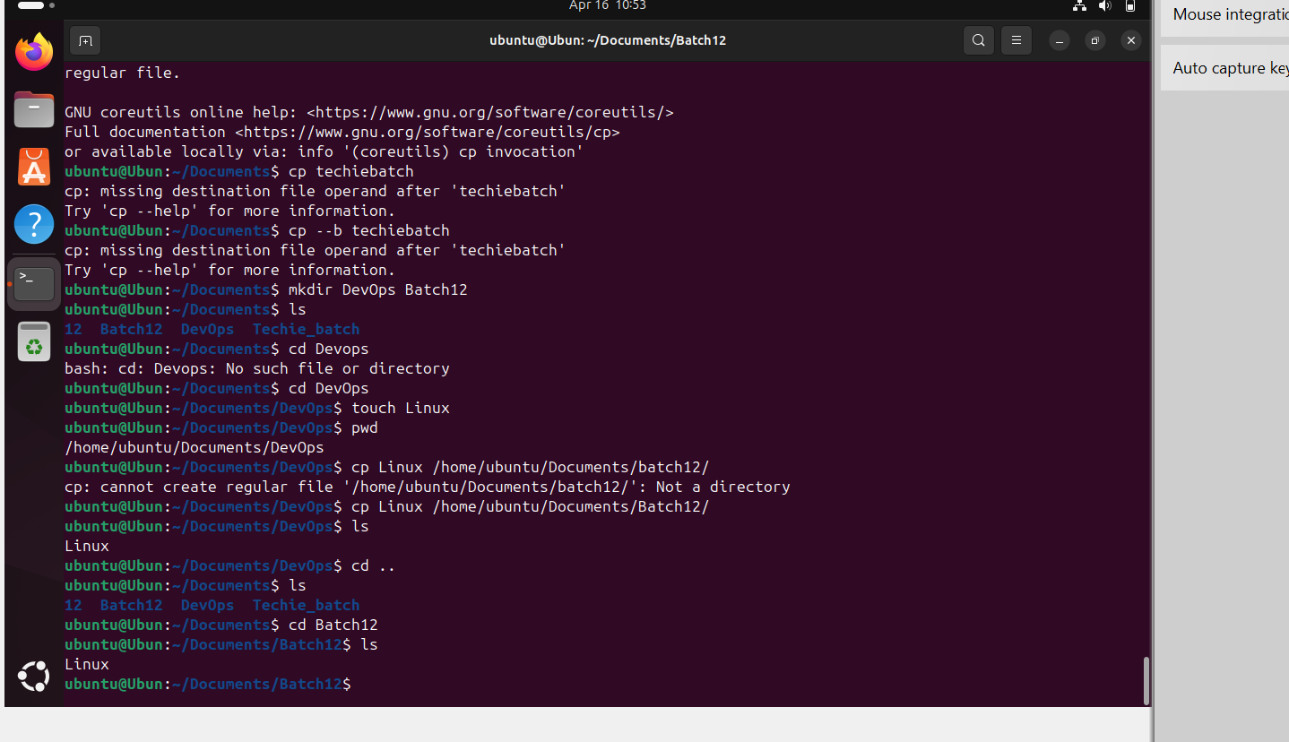21. touch- to create a file

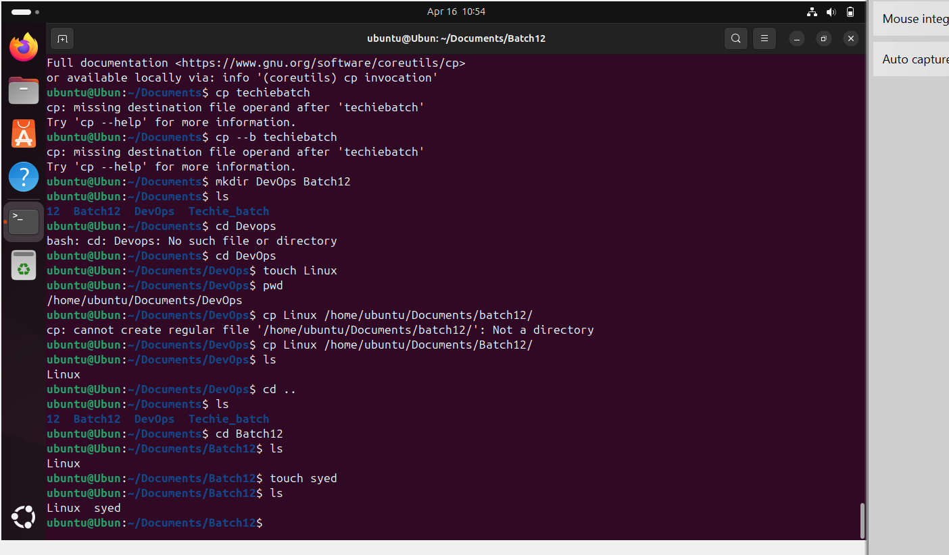

22. vi/vim/nano-- to add the text to the file

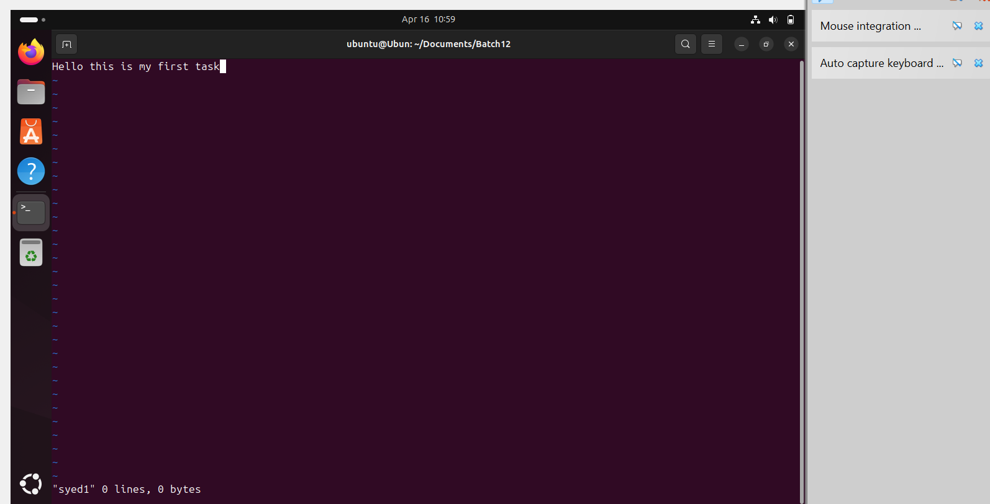

23. To save the text Esc:wq!

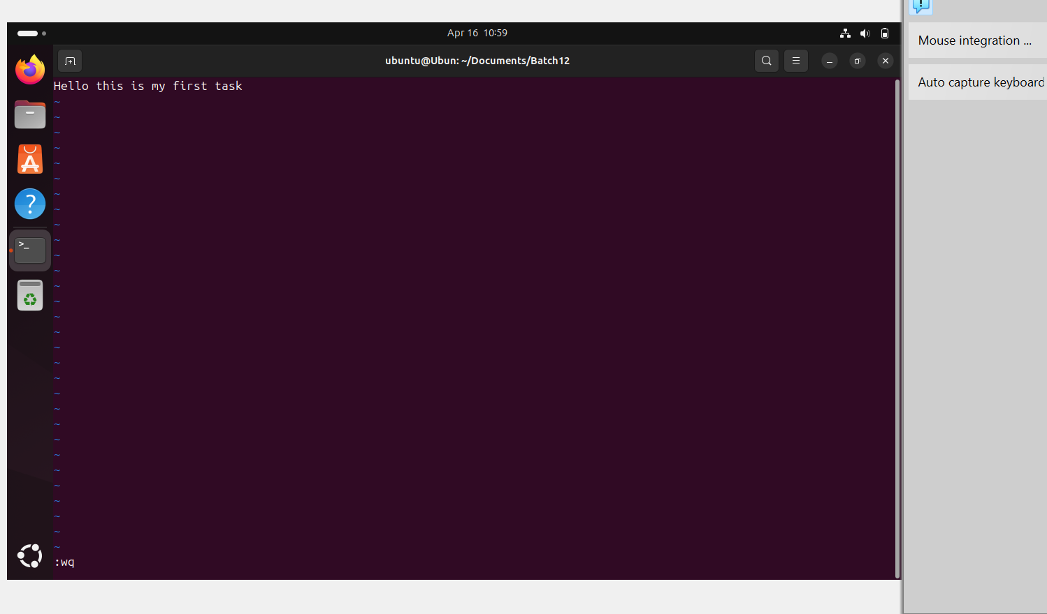

24. cat- to read the text/content in file

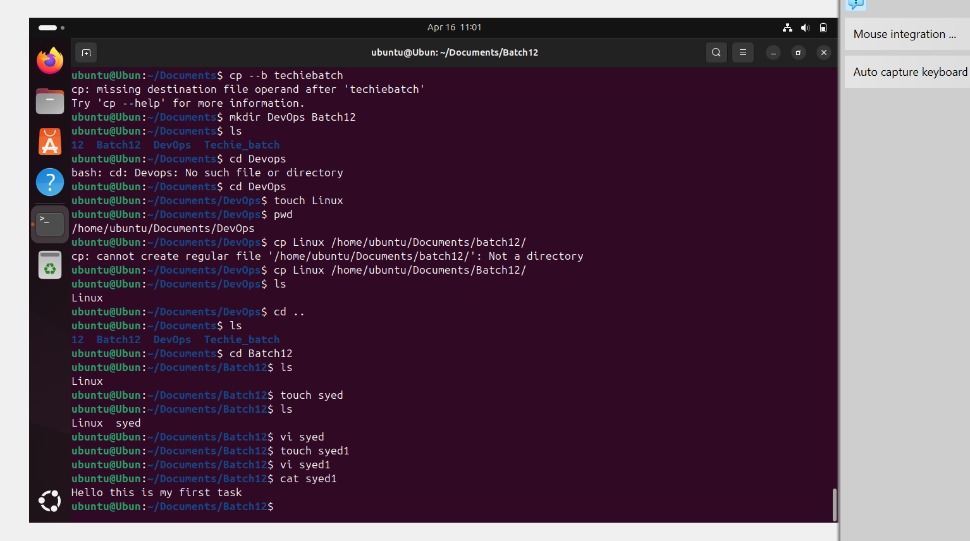

25. wc- word count in a file

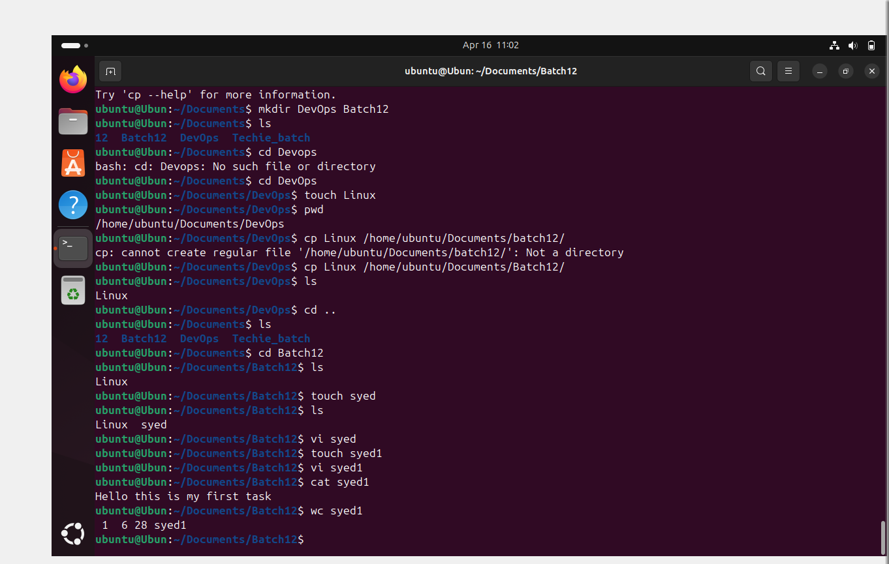

25. rm- to remove the file in a directory

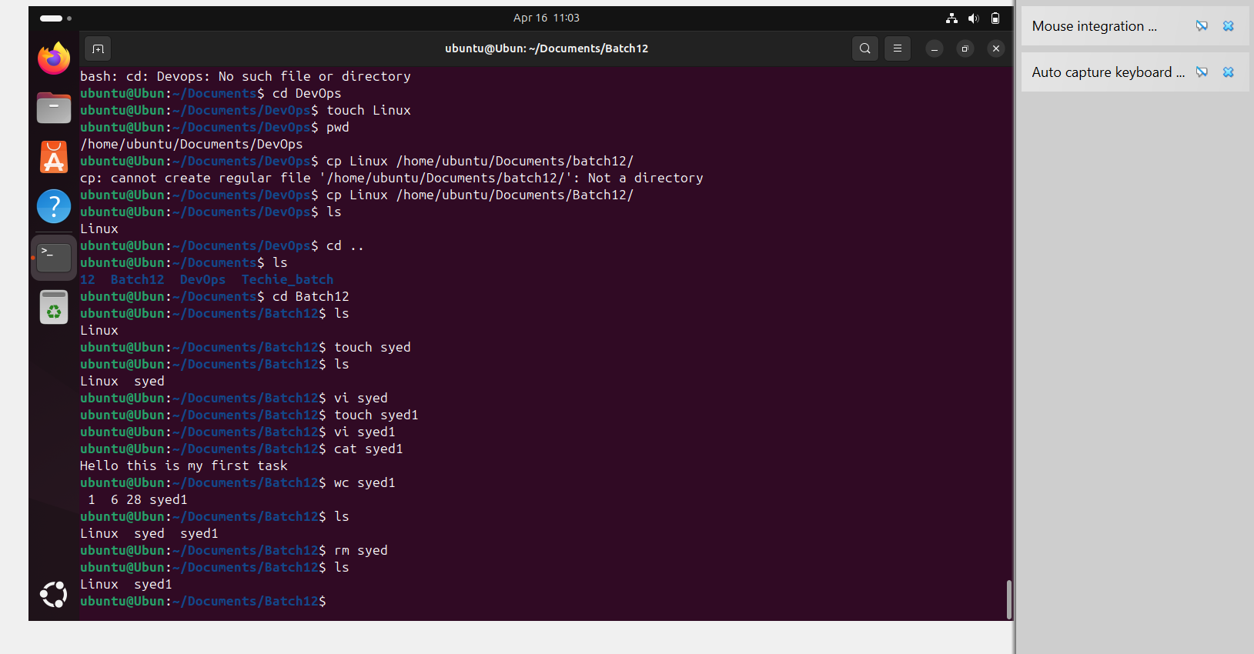

26. clear- to clear the command

